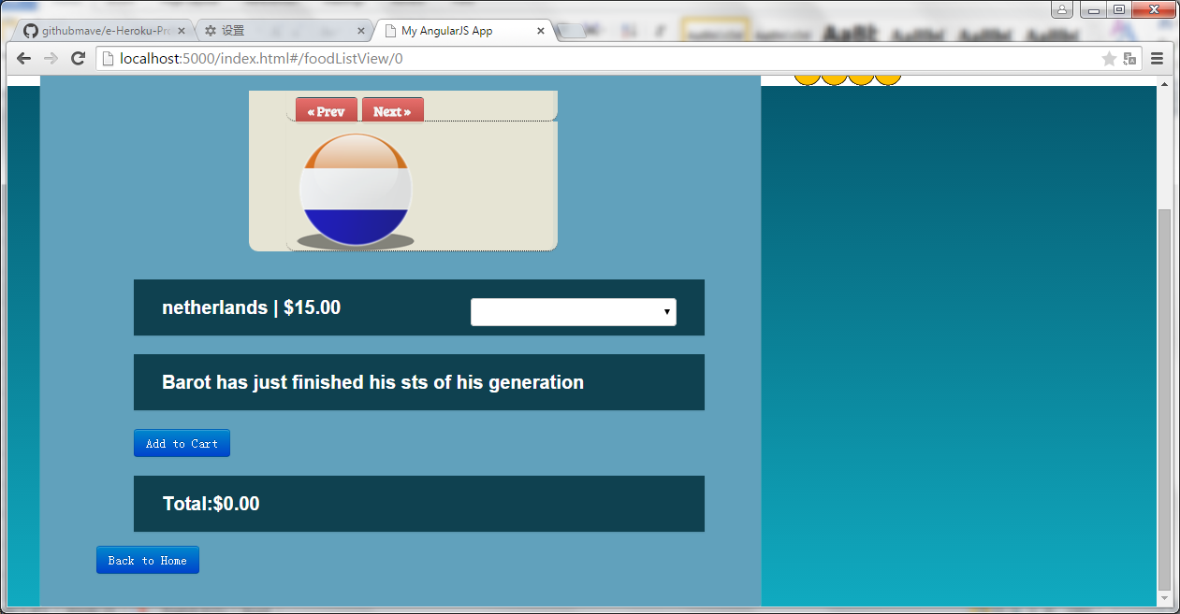

Right:

<a href="index.html"><input type="button" value="Back to Home" class="btn btn-primary"></a>

Wrong:

Back to Home button won’t work as below:

<a href="index.html"><button class="btn btn-danger">&lt; Back to Home</button></a>